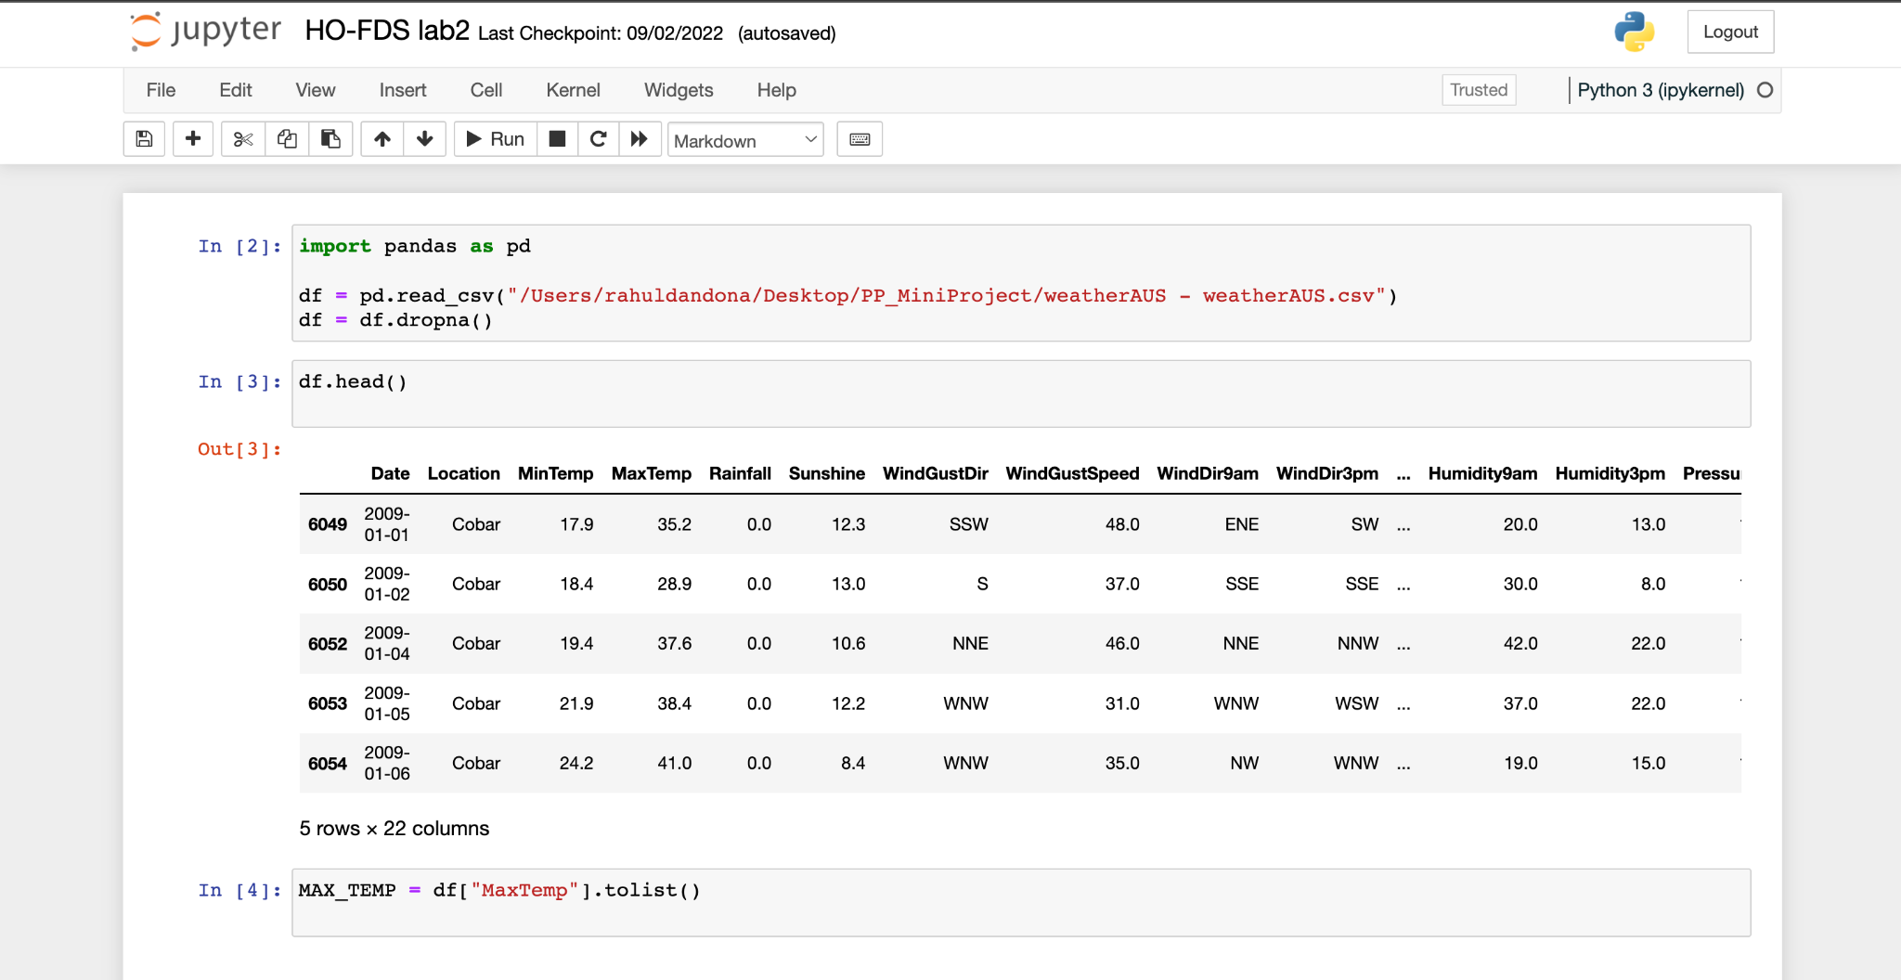

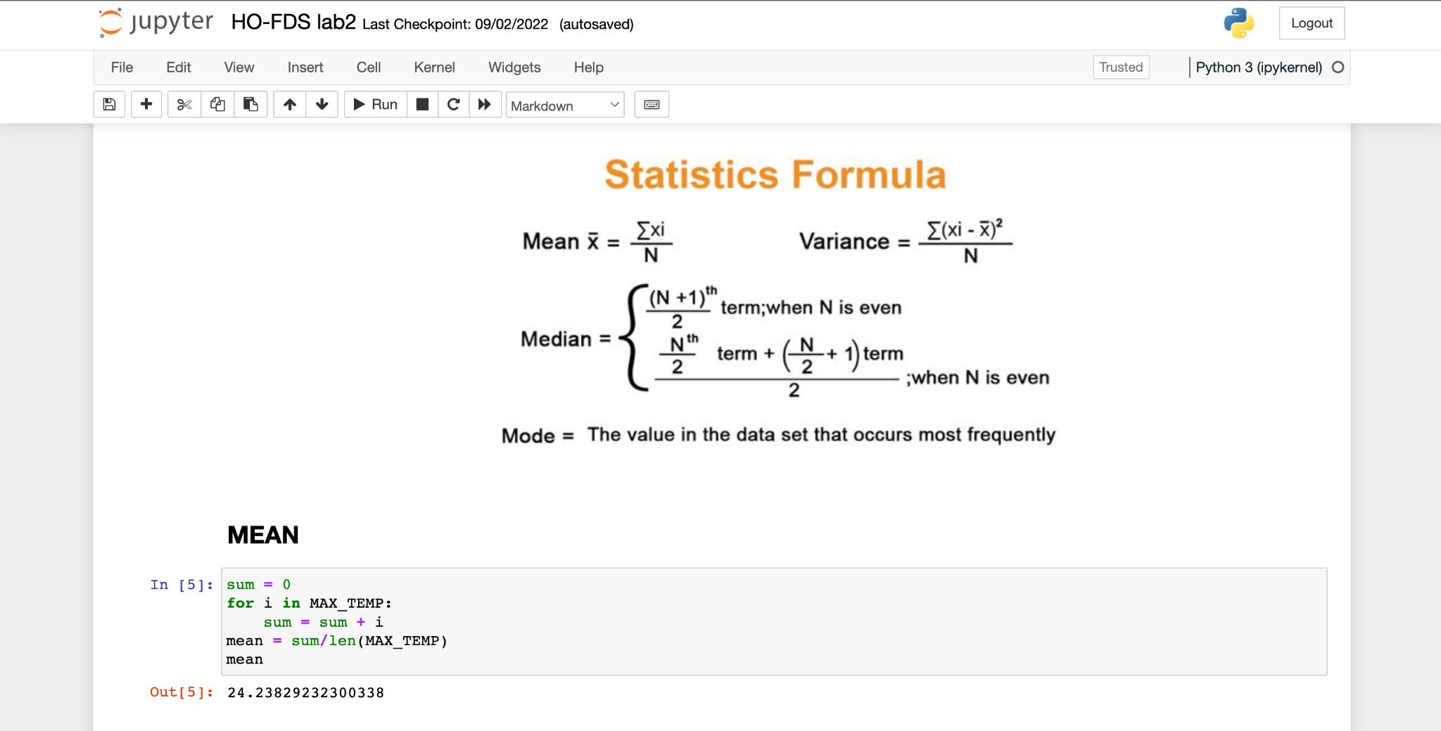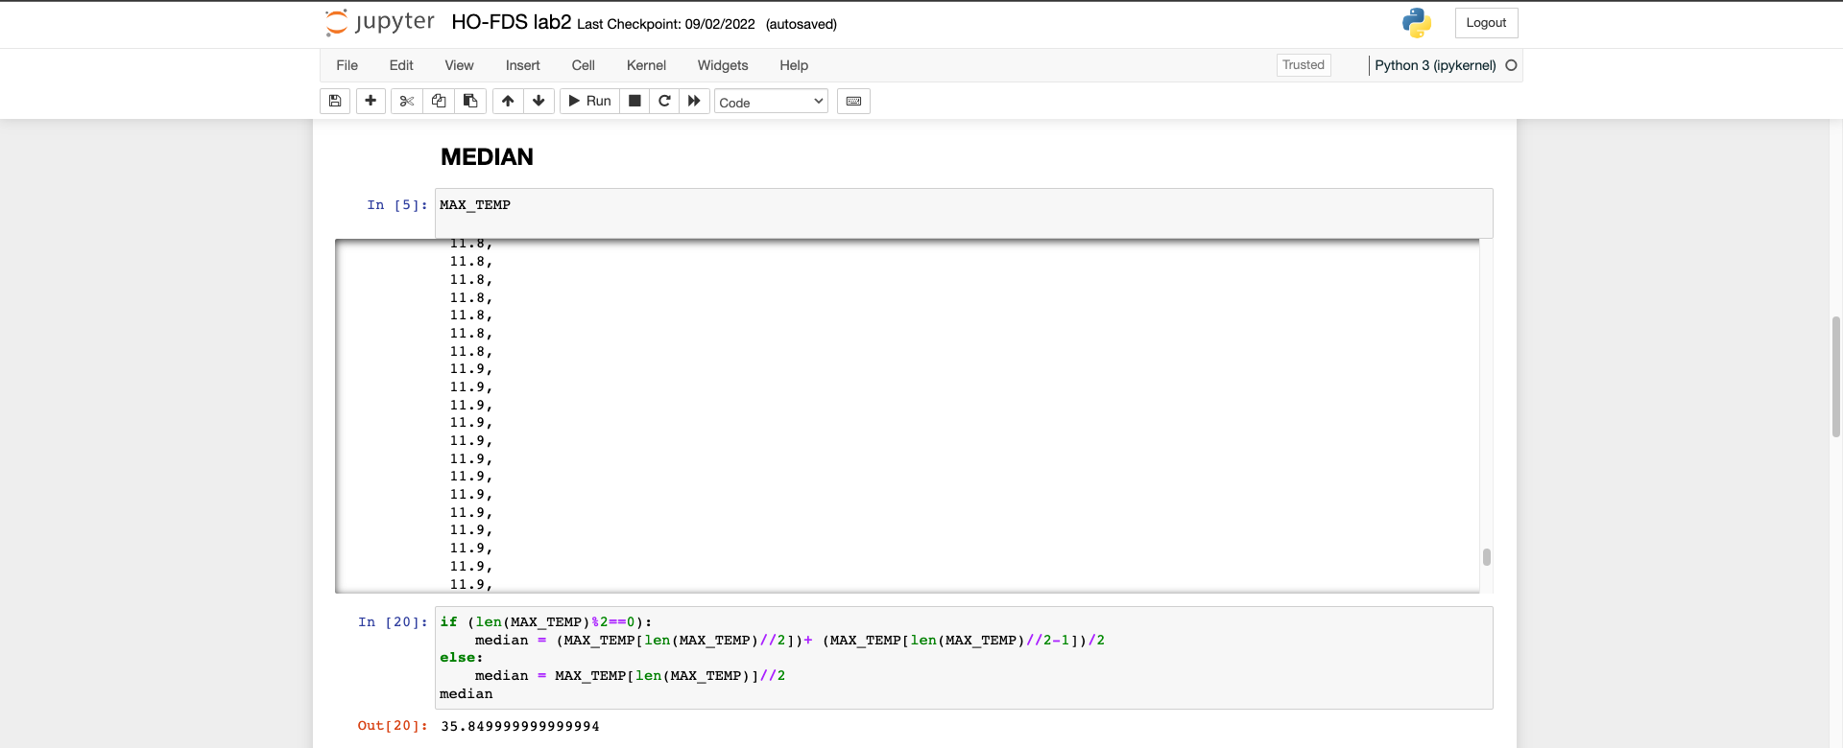

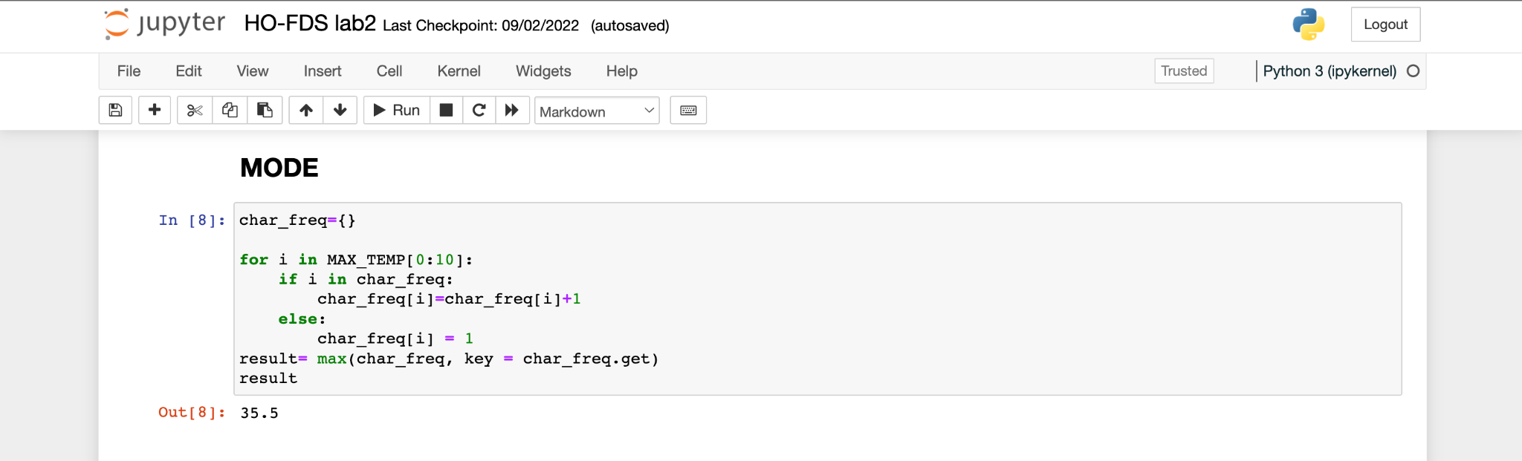

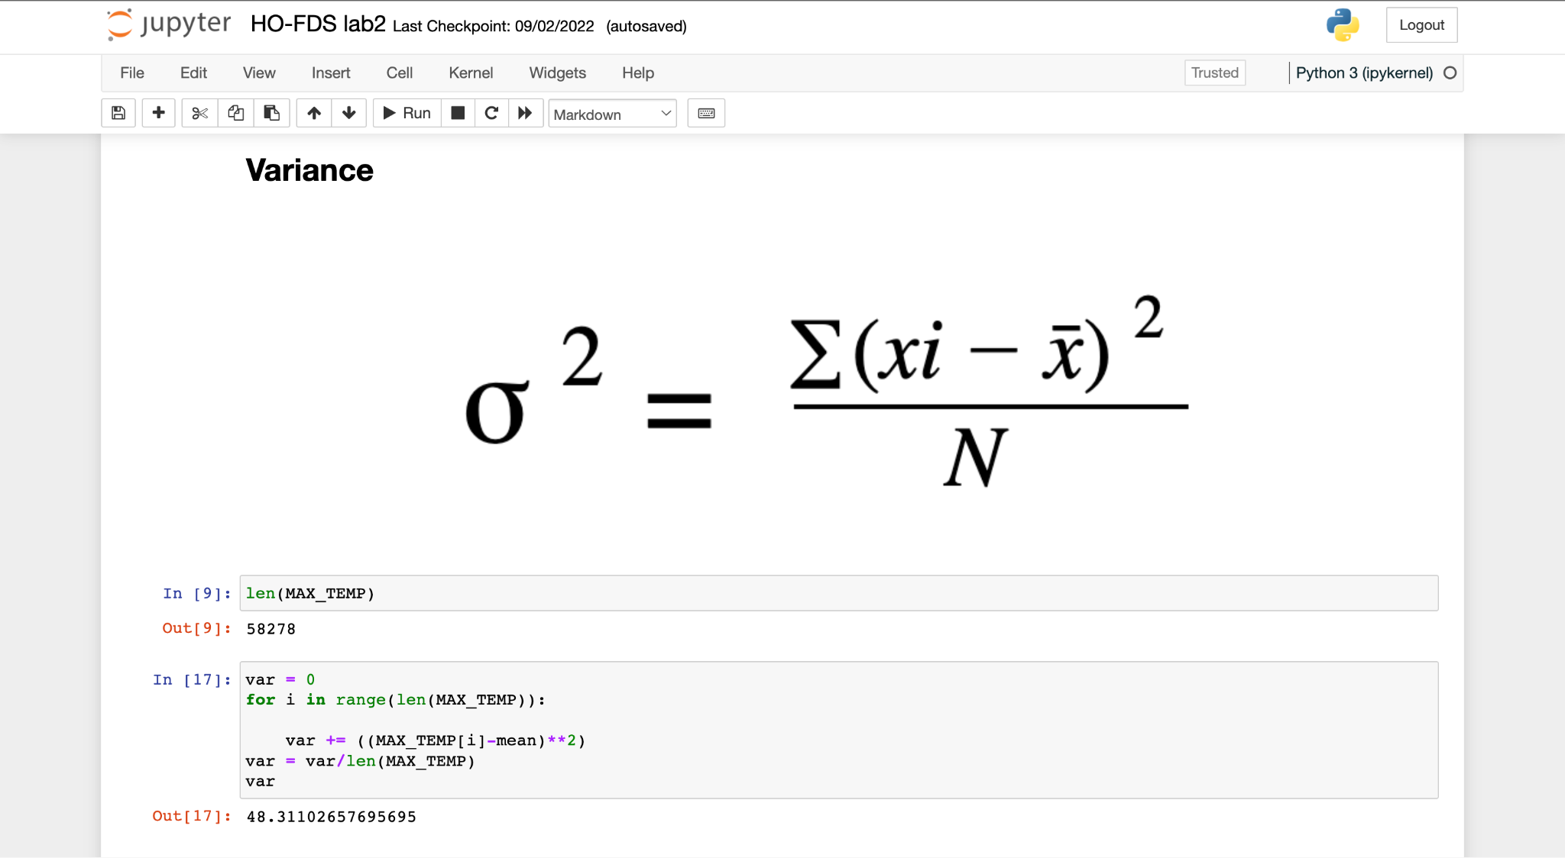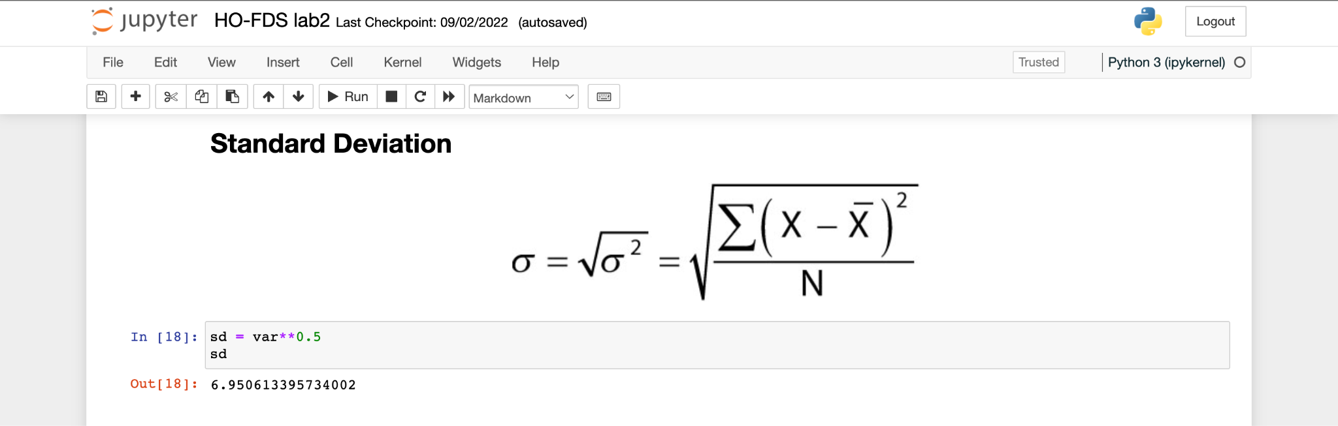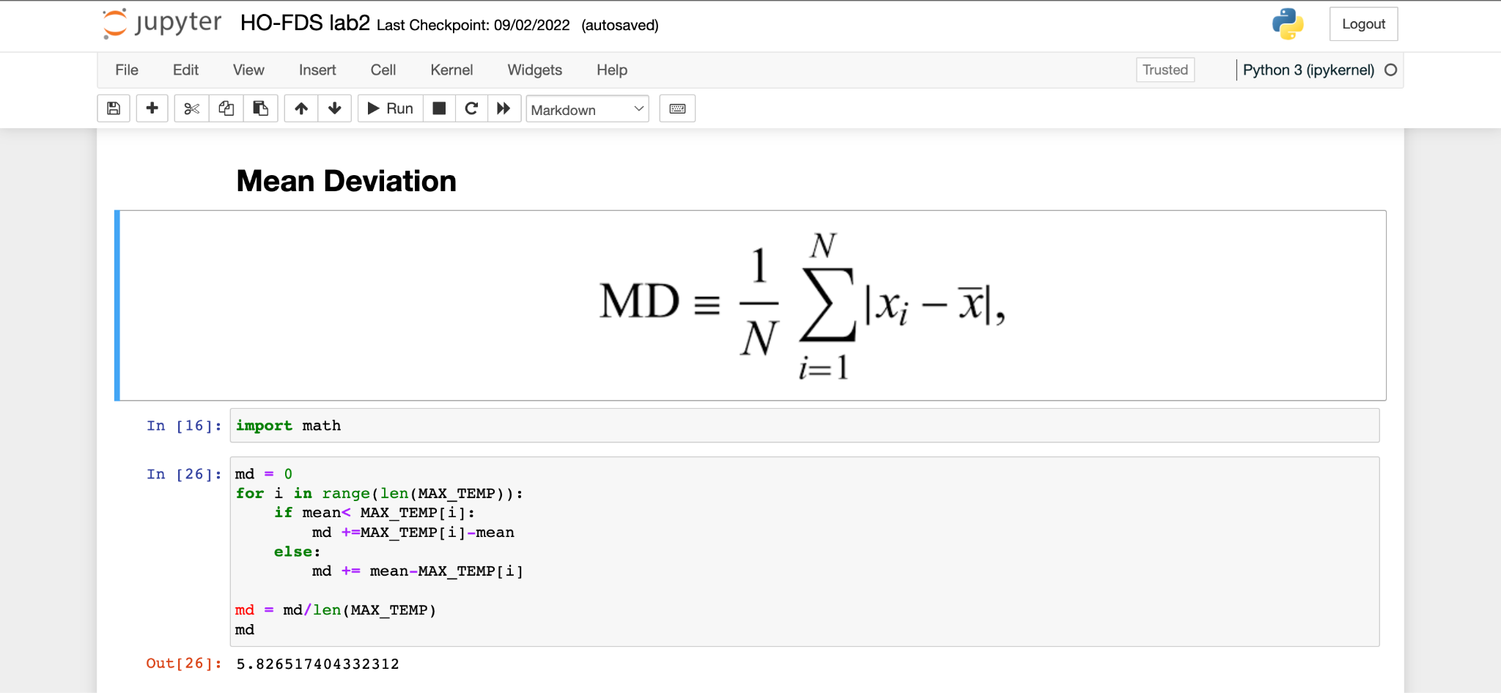

**POSTLAB QUESTIONS**

1. **What are the various applications of central tendency and variability of data?**

* **Central Tendency:**

Central tendency is a statistic that represents the single value of the entire population or a dataset. Some of the important examples of central tendency include mode, median, arithmetic mean and geometric mean, etc.

The purpose of the central tendency is to provide an exact representation of the entire collected data. It is often defined as the single value that is representative of the data.

It helps you understand the central value of a dataset, which tends to describe where the

data values typically fall.

For example, it helps us understand

1. **The typical home price in each neighborhood.**
2. **Average Temperature of a region.**
3. **Average Score of a cricket team over a period of time.**

* **Variability:**

In statistics, variability, dispersion, and spread are synonyms that denote the width of the distribution. Just as there are multiple measures of central tendency, there are several measures of variability. In this blog post, you’ll learn why understanding the variability of your data is critical. Then, I explore the most common measures of variability—the range, interquartile range, variance, and standard deviation. I’ll help you determine which one is best for your data.

For example, it helps us understand

1. **Stock Volatility.**
2. **Natural Disaster Management.**
3. **Bank Frauds - Tracking of unusual money transactions.**
4. **What are the outlier’s data? What are the different ways to find out it? Give suitable example with its effect on central tendency and variability of data?**

An outlier is an extremely high or extremely low data point relative to the nearest data point and the rest of the neighboring co-existing values in a data graph or dataset.

An outlier has to satisfy either of the following two conditions:

1. *outlier < Q1 - 1.5(IQR)*
2. *outlier > Q3 + 1.5(IQR)*

Outliers affect the mean value of the data but have little effect on the median or mode of a given set of data.

The outliers are non-randomly distributed, they can decrease normality. It **i**ncreases the error variance and reduces the power of statistical test. They can cause bias and/or influence estimates.

Outliers affect the mean value of the data but have little effect on the median or mode of a given set of data.